
22nd ACM SIGSPATIAL International Conference on
Advances in Geographic Information Systems (ACM SIGSPATIAL 2014)
November 4-7, 2014, Dallas, Texas, USA

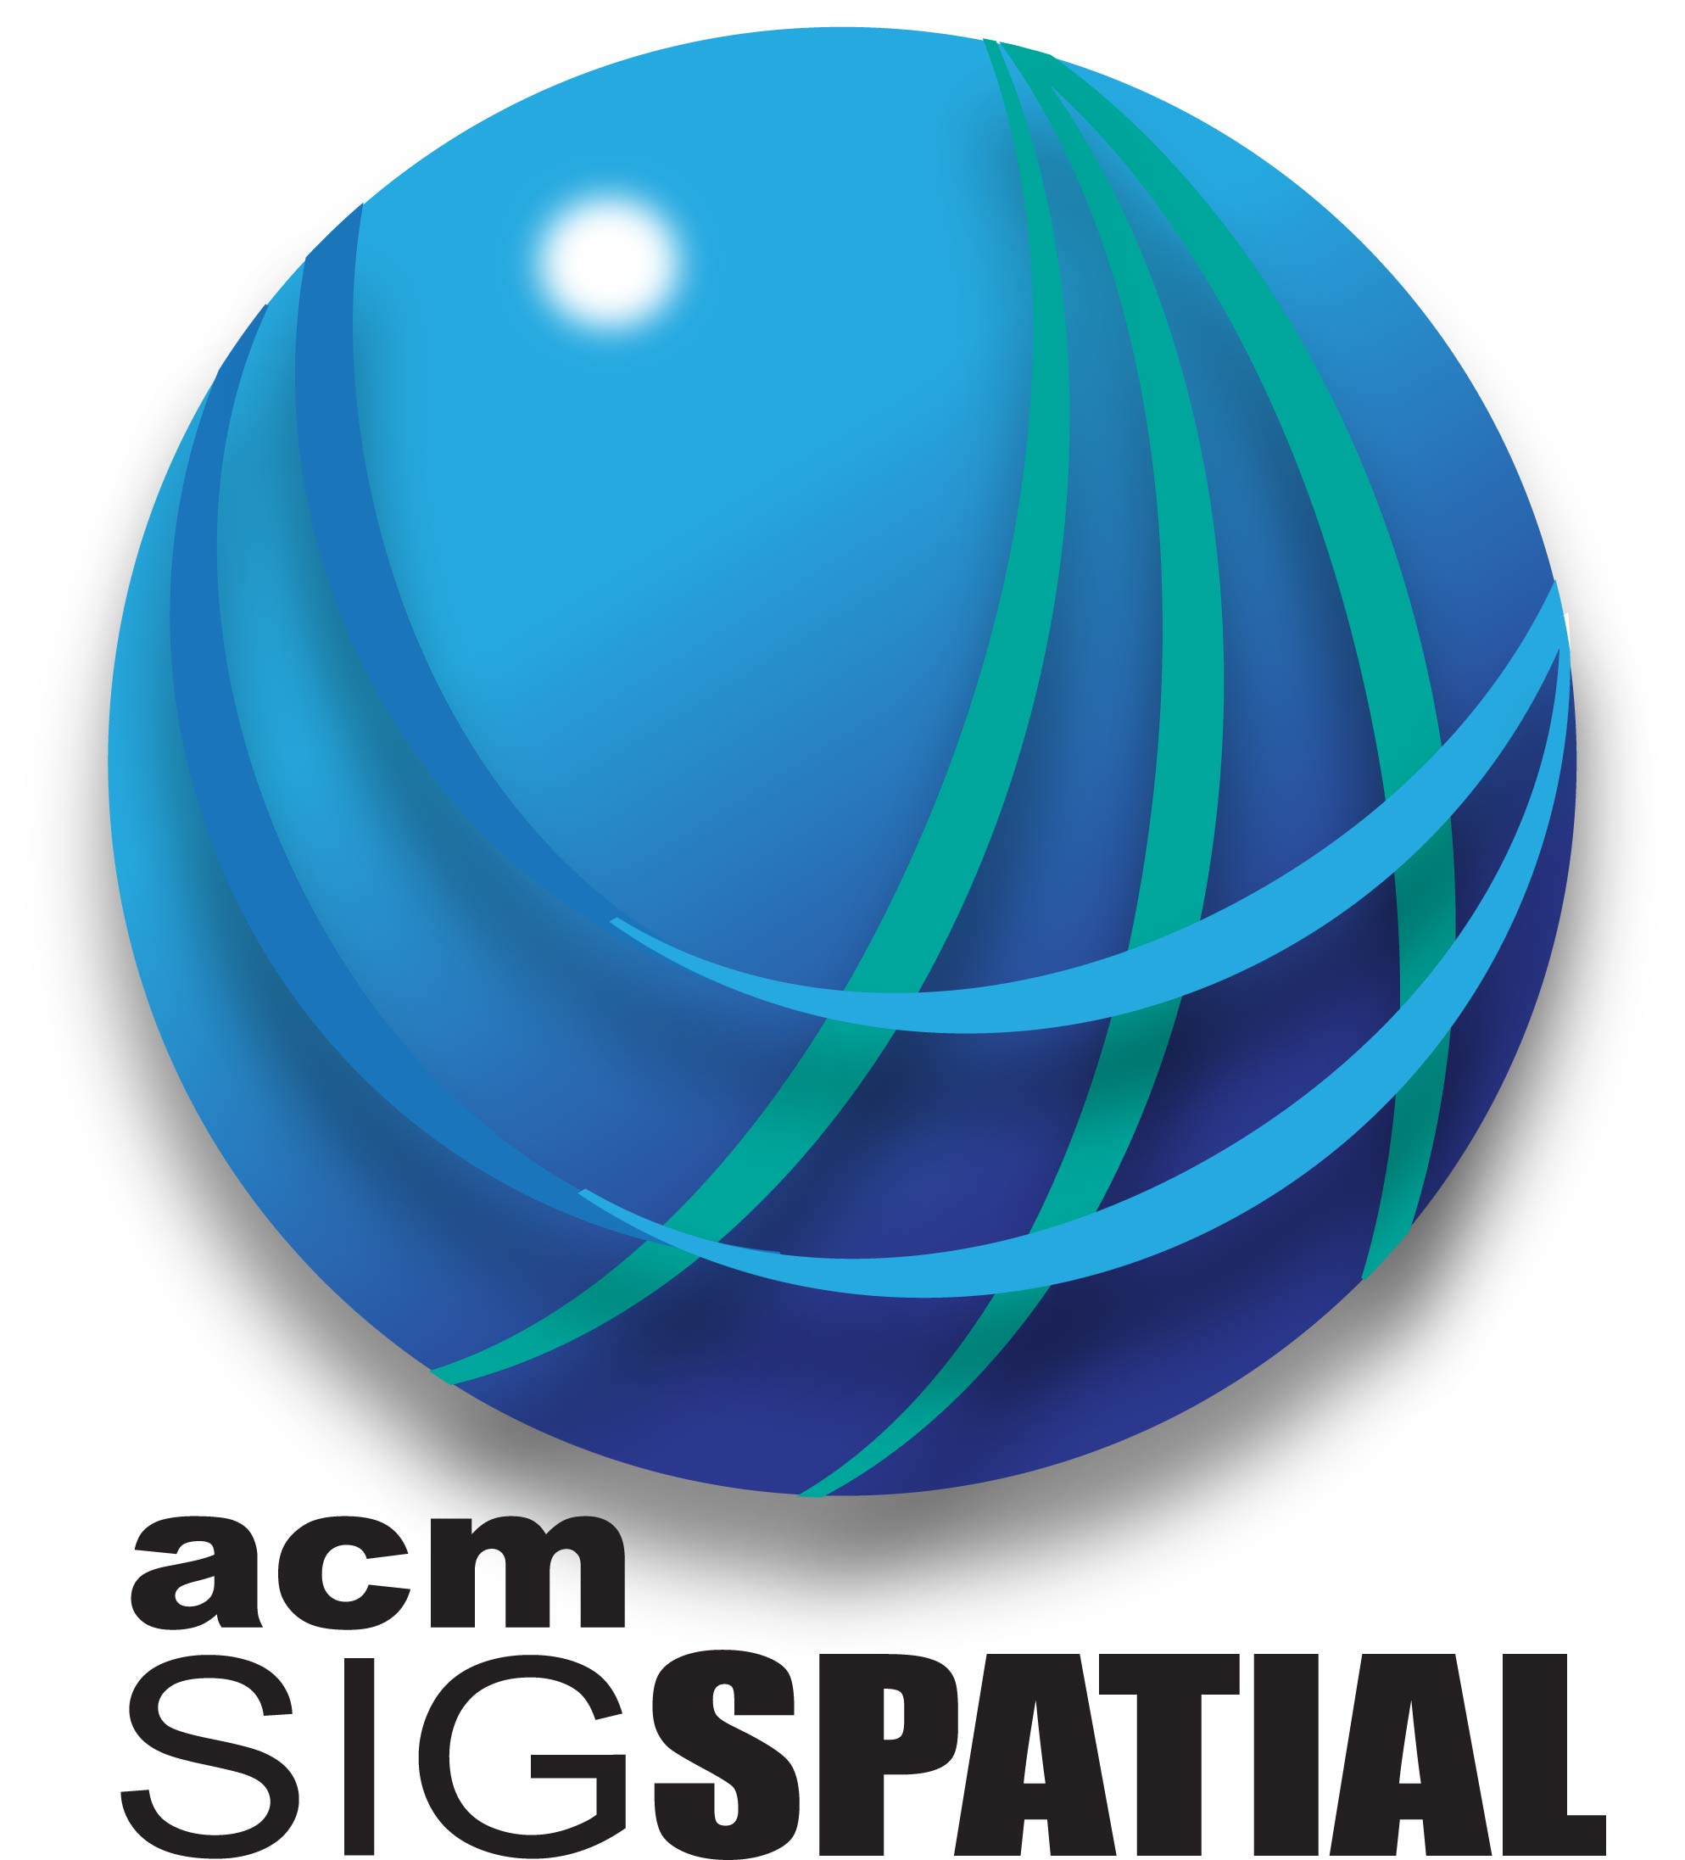

Conference Officers
General Chairs:
Yan Huang, U. N. Texas, USA
Markus Schneider, U. Florida, USA
Program Committee Chairs:
Michael Gertz, Heidelberg U., Germany
John Krumm, Microsoft Research, USA
Jagan Sankaranarayanan, NEC Labs, USA
Treasurer Chairs:
Jing (David) Dai, Google, USA
Local Arrangements Chair:
Bill Buckles, U. N. Texas, USA
Sponsors Chairs:
Franz Leberl, Graz U. of Technology, Austria
Mark McKenney, Southern Illinois U., USA
Cyrus Shahabi, U. Southern California, USA
Workshops Chairs:
Mohamed Mokbel, U. Minnesota, USA
Egemen Tanin, U. Melbourne, Australia
Publicity Chairs:
Mohamed Ali, Microsoft, USA
Hongrae Lee, Google Research, USA
Proceedings Chairs:

Matthias Renz, LMU Munich, Germany
Christian Sengstock, Heidelberg U., Germany
Poster Chairs:
Wei-Shinn Ku, Auburn University, USA
Ahmed Lbath, U. Grenoble 1 - Joseph Fourier, France
Contest Chairs:
Xin Chen, HERE/Nokia, USA
Siva Ravada, Oracle Corporation, USA
Registration Chair:
Chengyang Zhang, Teradata, USA
Webmaster:
Marco Adelfio, U. Maryland, USA

Important Dates (All Submissions)
Abstract Submission: June 24 (Midnight PDT)
Full Submission: July 1 (Midnight PDT)
Notification: August 26

Call for Research, Industrial, and Systems Papers, Demos, PhD Showcases, and Workshops
The ACM SIGSPATIAL International Conference on Advances in Geographic Information Systems 2014 (ACM SIGSPATIAL 2014) is the twenty second event in a series of symposia and workshops that began in 1993 with the aim of bringing together researchers, developers, users, and practitioners in relation to novel systems based on geo-spatial data and knowledge, and fostering interdisciplinary discussions and research in all aspects of geographic information systems. The conference provides a forum for original research contributions covering all conceptual, design, and implementation aspects of geospatial data ranging from applications, user interfaces, and visualization to data storage and query processing and indexing. The conference is the premier annual event of the ACM Special Interest Group on Spatial Information (ACM SIGSPATIAL). Researchers, students, and practitioners are invited to submit their contributions to ACM SIGSPATIAL 2014.
Suggested Geospatial-related topics include but are not limited to the following:

- Big Spatial Data  - Cartography and Geodesy  - Computational Geometry  - Computer Graphics Applications  - Computer Vision Applications  - Distributed and Parallel Algorithms  - Earth Observation  - Geographic Information Retrieval  - Geospatial Architectures and Middleware  - GPU and Novel Hardware Solutions  - Human Computer Interaction and Visualization  - Image and Video Understanding  - Location-Based Services  - Location Privacy, Data Sharing and Security  - Mobile Systems and Vehicular Ad Hoc Networks  - Object Tracking and RFIDs  - Performance Evaluation  - Photogrammetry  - Similarity Searching  - Spatial Analysis and Integration  - Spatial and Spatio-Temporal Data Acquisition | - Spatial Data Analytics  - Spatial Data Mining and Knowledge Discovery  - Spatial Data Quality and Uncertainty  - Spatial Data Structures and Algorithms  - Spatial Data Warehousing, OLAP, and Decision Support  - Spatial Information and Society  - Spatial Modeling and Reasoning  - Spatial Query Processing and Optimization  - Spatio-Temporal Data Analysis  - Spatio-Temporal Data Management  - Spatio-Temporal Sensor Networks  - Spatio-Temporal Stream Processing  - Spatio-Textual Searching  - Standardization and Interoperability  - Storage and Indexing  - Traffic Telematics  - Transportation  - Urban and Environmental Planning  - Visual Languages and Querying  - Web and Real-Time Applications

Paper Format: Manuscripts should be submitted in PDF format and formatted using the ACM camera-ready templates available at http://www.acm.org/sigs/pubs/proceed/template.html. It is important that previous related work (especially appearing in prior editions of the ACM SIGSPATIAL Conference and the ACM SIGSPATIAL workshops/symposia) be appropriately cited. All submissions will be refereed for quality, originality, and relevance by the Program Committee. Accepted papers will be considered for "Best Paper Award."
Research Papers: Authors are invited to submit full, original, unpublished research papers that are not being considered for publication in any other forum. Submissions are limited to 10 pages. In addition to the regular full-length papers, the Program Committee may accept some for poster presentation of the central idea for which a maximum of 4 proceedings papers will be allowed.
Industrial Experience and Systems Papers: Industrial Experience and systems papers are invited that describe original industrial experiences, challenges, and applications, as well as systems to be presented during the conference. Industrial Experience and Systems paper submissions are limited to 10 pages -- append "(Industrial Paper)" or "(Systems Paper)" to the title as is appropriate. Accepted Industrial Experience and Systems papers will appear in the conference proceedings.
Ph.D. Dissertation Showcase Papers: Ph.D. students are encouraged to submit their Ph.D. research contributions and work-in-progress, limited to 6 pages -- append "(Ph.D. Showcase)" to the title. Student authors of accepted papers will be able to present a summary of their research at the conference. Successful Ph.D. showcase papers will appear in the SIGSPATIAL Newsletter.
Demonstration Papers: Authors are invited to submit demo papers describing original demonstrations to be presented at the conference. Submissions are limited to 4 pages -- append "(Demo Paper)" to the title. Accepted demo papers will appear in the conference proceedings.
Presentation: At least one author per accepted paper, poster, Ph.D. Dissertation showcase, industrial paper, or demo must register and attend the conference to present the accepted submission. Otherwise, the accepted submission will not appear in the published conference proceedings or in the ACM Digital Library version of the conference proceedings.
Workshop Proposals: One-day workshops will be held on November 4, 2014. Workshop proposals are to be submitted in PDF format to the Workshops Chair. The proceedings of the workshops will appear in the ACM Digital Library. All proposers and organizers of accepted workshops must register for the workshop or the workshop will be canceled. Workshop proposal submission deadline is May 1, 2014.
Programming Contest: The ACM SIGSPATIAL CUP 2014, with prizes, is a geospatial-focused algorithm competition. See http://sigspatial2014.sigspatial.org/ for further details.

